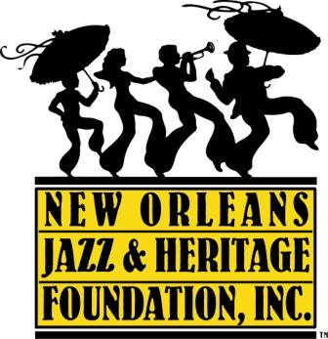

CLASS GOT BRASS
RECOMMENDED SONG LIST

All competing bands must perform one dirge and one up-tempo song.

DIRGES:

A Closer Walk With Thee
https://www.youtube.com/watch?v=MkfTgP04ZZ4

The Old Rugged Cross
https://www.youtube.com/watch?v=lQT7LBMrEHU

In the Sweet Bye and Bye
https://www.youtube.com/watch?v=w-fiJO5_D5o

Amazing Grace
https://www.youtube.com/watch?v=GvqBNp_LEqk

Flee As a Bird
https://www.youtube.com/watch?v=nP2nCJXkGKA

St. James Infirmary
Hot 8 Brass Band - St. James Infirmary (Official Video) - YouTube

UP-TEMPO SONGS:

I’ll Fly Away
https://www.youtube.com/watch?v=apCPrSQzgdQ

Joe Avery’s Blues aka The Second Line
https://www.youtube.com/watch?v=a6Woegchj04

Lil Liza Jane
Little Liza Jane - YouTube

Lord Lord Lord
https://www.youtube.com/watch?v=HlnDq_a_JLg

Over In the Gloryland
https://www.youtube.com/watch?v=_9iZuUK7NvQ

Paul Barbarin’s Second Line
https://www.youtube.com/watch?v=B52hguSifas&feature=youtu.be

Bourbon Street Parade
Bourbon Street Parade - YouTube

When the Saints Go Marching In
https://www.youtube.com/watch?v=1uLaGQzKcYw

Whooping Blues
https://www.youtube.com/watch?v=58Nqrrmv5jQ

Casanova
Cassanova - YouTube

Do Whatcha Wanna
https://www.youtube.com/watch?v=X_AOwrXev60

Go to the Mardi Gras
https://www.youtube.com/watch?v=z_4N6DEiyCQ

Let Your Mind Be Free
https://www.youtube.com/watch?v=awCy-529Q3g

My Feet Can’t Fail Me Now
https://www.youtube.com/watch?v=ASGn9H5fdPM

Tuba Fats
https://www.youtube.com/watch?v=i9q5Sbj3km4

Gimme My Money Back
https://www.youtube.com/watch?v=2KyvXtpY45I

AP Touro
Rebirth Brass Band - AP Touro - YouTube

Food Stamp Blues
Food Stamp Blues - YouTube

You Don’t Want to Go to War (clean version, please)
You Don't Want to Go to War - YouTube

Red Dress
Red Dress (aka Hi-Heel Sneakers) - YouTube

Lil Rascals
Knock With Me - Rock With Me - YouTube

